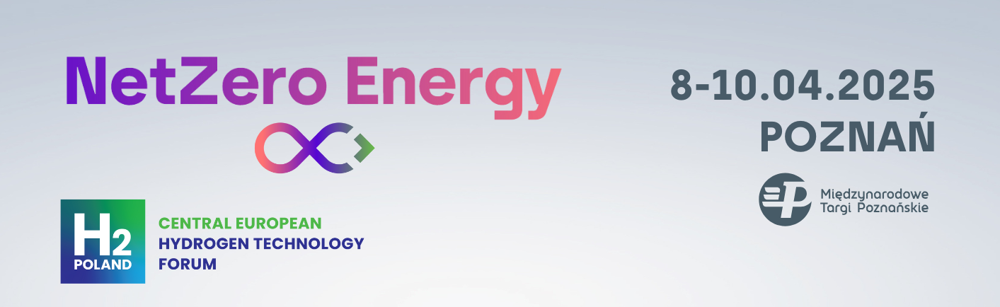

**Press release** Poznań, 21.01.2025

**NetZero Energy i H2POLAND – Join the leaders of green transformation!**

**Poznan will become the center of green energy transition in April. On April 8-10, 2025, NetZero Energy and H2POLAND - one of the most important meetings of the decarbonization industry in Central and Eastern Europe - will be held at the Poznań International Fair.**

The event, in a conference and exhibition format, will bring together key leaders and experts from Poland and Europe to discuss the future of energy and the decarbonization of the industry.

Piotr Drozdowski, director of NetZero Energy and H2POLAND, stresses that environmental and climate challenges play an important role in the development of the modern economy. - In order to achieve ambitious goals, it is necessary not only to reduce greenhouse gas emissions and move away from coal technologies, but above all to dynamically develop technologies related to renewable energy sources, nuclear power and innovative energy storage solutions, says P. Drozdowski. In addition, CCS technologies, alternative fuels and hydrogen will become key pillars of the energy transition.

Participants in the event will have the opportunity to listen to lectures and panel discussions on six special thematic stages, where experts will address renewable energy sources, energy storage, hydrogen technology, industrial decarbonization and nuclear power. Discussions will cover issues such as the cost-effectiveness of RES investments, the role of energy storage in ensuring energy security, the prospects for the hydrogen sector, the challenges of the European Green Deal, and the impact of the transition on industrial competitiveness in a global context. In addition, the program will include topics related to synthetic fuels, district heating and energy education.

An integral part of the event will be an exhibition zone, where companies will showcase their latest technologies and innovative solutions to support the energy transition and decarbonization of the industry.

The event is aimed at representatives of a wide audience, including leaders of CO₂-neutral industry, energy producers and distributors, energy management experts, the mobility sector, public administration, as well as researchers and innovators.

The NetZero Energy and H2POLAND Forum will be held at the Poznań International Fair. This is a unique opportunity to meet with leaders of the green transformation and shape the energy future together.

**NetZero Energy and H2POLAND Central European Hydrogen Technology Forum will be held at the Poznań International Fair on April 8-10, 2025.**

More information at:

<https://netzeroenergy.pl/en>

<https://h2poland.com.pl/en>